RESPOND BY: January 26, 2022
OUTREACH NOTICE

GS-0482-9/11 Fisheries Biologist
Pisgah National Forest - Pisgah Ranger District
Temporary promotion, Not to Exceed (NTE) one year
NFs in North Carolina
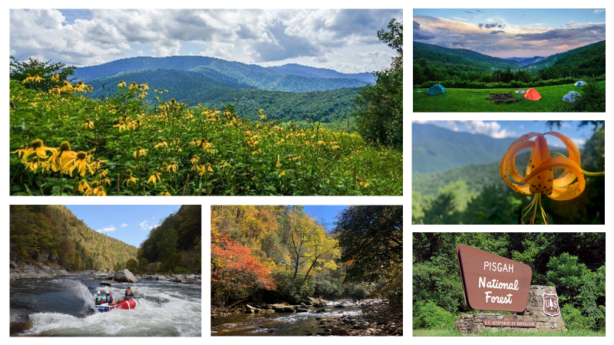
Are you ready for the next step of your Federal Career?
_____________________________________________________
GS-0482-9/11 Fisheries Biologist
Pisgah Zone, National Forests of North Carolina
Pisgah Ranger District

The purpose of the outreach is to notify potential candidates about this upcoming not to exceed one year appointment opportunity. This position is located on the Pisgah National Forest (zone) that consists of three districts (Appalachian RD, Pisgah RD, and the Grandfather RD). The duty station for this position is the Pisgah Ranger District. However, this detail is being outreached as virtual with potential for occasional travel to the duty station or temporary relocation to duty station for the duration of the NTE. If you are interested in this opportunity please respond in the Outreach Database and send your Outreace Response Form and resume to: Jason Herron. jason.herron@usda.gov Please indicate what GS level applies to you and which option of virtual or temporary relocation you are interested.
About the Position:
This position is responsible for an active fisheries program and specialist responsibilities for a busy planning schedule on the Pisgah Zone which is comprised of the Appalachian, Grandfather and Pisgah Ranger Districts of the Pisgah National Forest located in the heart of the Blue Ridge Mountains. The zone districts host some of the most iconic landscapes in the Appalachian Mountains including Mount Pisgah and the Cradle of Forestry, Mount Mitchell, the highest peak in the eastern U.S., and Linville Gorge, the “Grand Canyon of North Carolina”. The ecology of the area represents some of the most unique and diverse habitats known on earth. Duties for the position include: providing technical expertise for the zone in matters dealing with threatened, endangered, and sensitive aquatic species as well of other aquatic species of interest; serving as the fisheries and aquatic habitat expert when working on or leading interdisciplinary teams; preparing biological evaluations and assessments; leading ecosystem restoration activities that focus management of aquatic habitat for a diverse range of species; building collaboration and working with partner groups such as the NC Wildlife Resources Commission and Trout Unlimited to plan and implement fisheries projects; maintaining database records; and developing annual workplans and budgets.
Some of the priority items needed during this detail may be:
- Report bi-weekly to the Pisgah Zone Rangers of upcoming projects and program needs
- Serve on an interdisciplinary team for projects with a wildlife biologist, botanist, Environmental coordinator and archeologist with other resource project leaders
- Work with the NC Wildlife Resources Commission on Brook trout restoration projects, trout monitoring, hellbender population surveys and hellbender long term studies with universities.
- Serve on the Pisgah Zone NEPA team providing an aquatic resource report, drafting biological evaluations and decision memos. Also attends project planning meetings providing input for the protection and restoration of aquatic organisms.
- Provide leadership for the River Ranger Program which includes Supervising the Lead River Ranger, going into the field with the river ranger team- providing oversight to operations and outreach and education programming. Be the point of contact for partners of the river ranger program including the director of the Pisgah Conservancy and Trout Unlimited. Also provide materials and supplies that the program would need.
- Work closely with the Forest Hydrologist on stream restoration projects.
- Report fiscal accomplishments through the Watershed Inventory Tracking program
- Provide Outreach and Education to the community
- Serve as the liaison with Trout Unlimited including providing 1/4ly updates of partner projects.
- Provide input for the Great American Outdoors Act, Infrastructure bill, and storm recovery projects that pertain to stream restoration, stream crossing improvements or access
- Provide resource information for permit requests
- Provide leadership for watershed inventory projects with partners such as Trout Unlimited
- Update agreement information with partners as needed

The National Forests in North Carolina:

The Nantahala, Pisgah, Uwharrie, and Croatan National Forests make up the National Forests in North Carolina. Combined, the National Forests in North Carolina are among the most visited National Forests in the nation. The four national forests encompass 1.25 million acres, featuring ecosystems from the mountains to the sea. The Nantahala and Pisgah National Forests each contain more than 500,000 acres, the Uwharrie National Forest is the smallest unit with more than 50,000 acres, and the Croatan National Forest is more than 160,000 acres.

Additional Information:
The town of Pisgah Forest is located near Brevard. For more information about the community, visit the Brevard/Transylvania website at http://www.brevardncchamber.org or by calling (828) 883-3700.

THANK YOU for your interest.

The USDA is an equal opportunity provider, employer, and lender.

The U.S. Department of Agriculture (USDA) prohibits discrimination in all its programs and activities on the basis of race, color, national origin, gender, religion, age, disability, political beliefs, sexual orientation, and marital or family status. (Not all prohibited bases apply to all programs.) Persons with disabilities who require alternative means for communication of program information (Braille, large print, audiotape, etc.) should contact USDA's TARGET Center at (202) 720-2600 (voice and TDD). To file a complaint of discrimination, write USDA, Director, Office of Civil Rights, Room 326-W, Whitten Building, 14th and Independence Avenue, SW, Washington, DC 20250-9410 or call (202) 720-5964 (voice and TDD). USDA is an equal opportunity provider and employer.
NATIONAL FORESTS OF NORTH CAROLINA
Outreach Response Form

Zone Fisheries Biologist, GS-0482
Pisgah Ranger District
Pisgah Forest, NC

Please Reply by January 26, 2022

Name:
Email Address:
Mailing Address:
Phone:
Current Agency or Forest:
Current Job Title, Series and Grade:

If you are not a status (career or career conditional) permanent employee, please check the following special authorities that you are eligible for:

Reinstatement Eligible ☐
Person with Disability ☐
Veterans Readjustment ☐
Disabled Veteran w/30% Compensable Disability ☐
Veterans Employment Opportunities Act of 1998 ☐
Former Peace Corps Volunteer ☐
Student Career Experience Program ☐
Land Management Workforce Flexibility Act ☐
Other:

Additional questions:

- Do you qualify for a GS 9 or GS 11 position?
- Would you be interested in a virtual only position, a temporary change of duty station, or either?

We appreciate your interest in this position. Please respond by email with the outreach form questions above, attach a resume, and also respond in the outreach database.

Jason Herron
Email: jason.herron@usda.gov

